**What is going to happen? Where does it take place? What is the story?**

The story is about the King and is inspired by the game Dungeons & Dragons (2023). A user reached a kingdom and met King Eloon. The User is a distant relative of King Rusk. Then King asks the User what’s the name of the User. In turn, the User will reply with his name.

King asks the User if the User wants to get a fortune, then the User needs to cross four dungeons, and at the fifth dungeon, user will find a jewelry box and collect at least four items in the backpack including health, Money holder, dollar, and key. But if he gives the wrong command, a random article will be dropped off from the backpack.

**Here is the map of the game:**

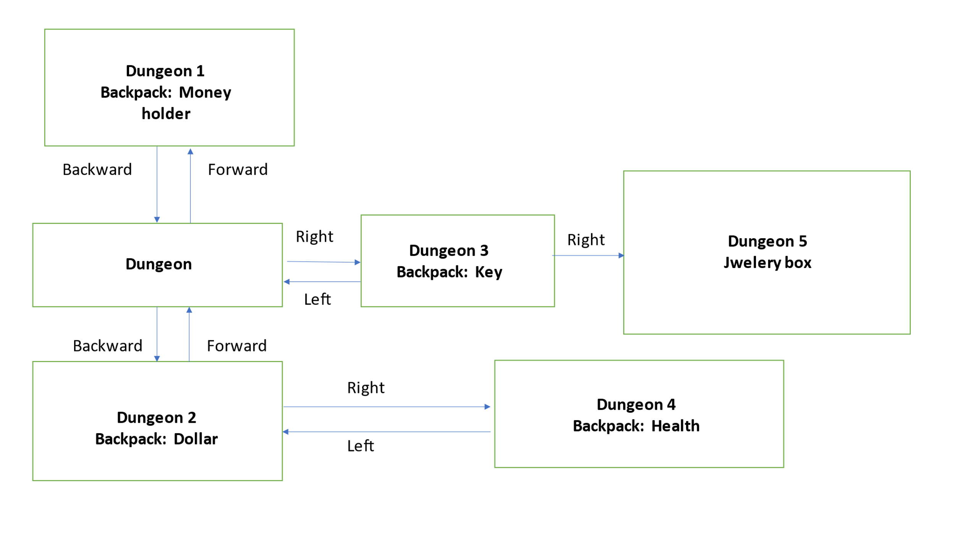

Initially, the User will be at Dungeon. He can either go forward to Dungeon 1 and receive the Money holder, go backward to Dungeon to receive the Dollar or go right to receive the key. When the User reaches Dungeon 2, he can go right again to receive health; further, come back to Dungeon, and again go right to Dungeon 3 to receive key, and then right to Final Dungeon 5 to Open the jewellery box.

References:

(n.d.). Dungeons & Dragons: Honor Among Thieves. IMDB. Retrieved October 29, 2023, from https://www.imdb.com/title/tt2906216/